UNIT 2
LESSON 1 – MY LIFE ON A FARM

- 1 Read about Kira and her life on a farm.
Pročitaj tekst o Kiri i njezinoj obitelji.

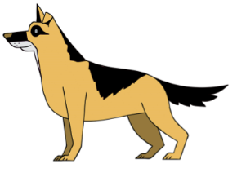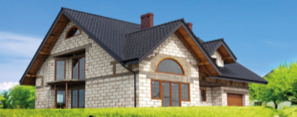
Hello! My name is Kira. My home is a farm.
Bok! Moje ime je Kira. Moj dom je farma.

There are five (5) humans on the farm.
Na farmi živi pet (5) ljudi.

There is also a pony 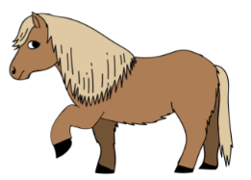 , a donkey 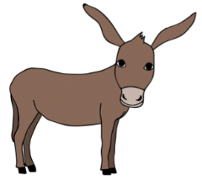
Tu žive još i poni, magarac

and a cat Jinx 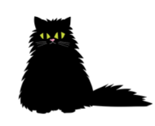.
i mačak Jinx.

In the house, there is a place where my family makes food.
U kući je mjesto gdje moja obitelj priprema hranu.

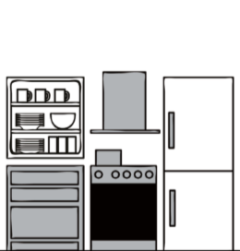

There is a small room where they keep fruit, vegetables
Tamo je i mala soba gdje drže voće, povrće
and my delicious snacks.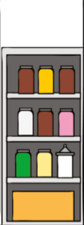
i moje poslastice.
There is a place where they eat. 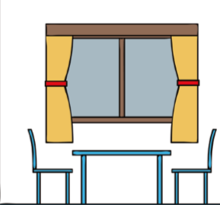
Tamo je i mjesto gdje jedu.

There are three (3) sleeping places. 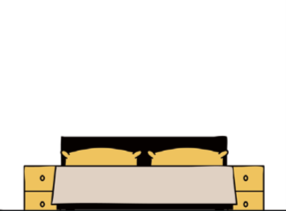
Tamo su tri mjesta za spavanje.
There is a place where my family gets clean. 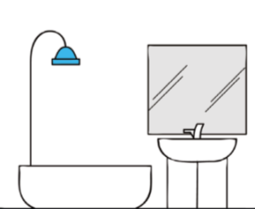
Tamo je mjesto gdje se moja obitelj redi / čisti.

There is a room where they all sit or lie down and watch TV.
Tamo je soba gdje svi sjede ili leže i gledaju televiziju.

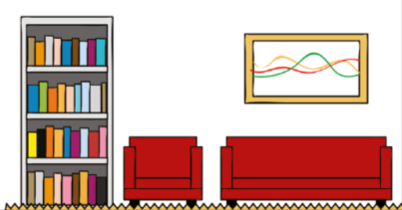

That is my favourite room. Someone always pets me there.
To je moja omiljena soba. Tamo me uvijek netko mazi.

- 2 Take a look at Kira’s family house.
Pogledaj kuću Kirine obitelji.
What rooms are in this house? Name them in Croatian.
Koje su prostorije kući (na slici)? Imenuj ih na hrvatskom.
Show the room where Kira’s family eat.
Pokaži sobu u kojoj Kirina obitelj jede.

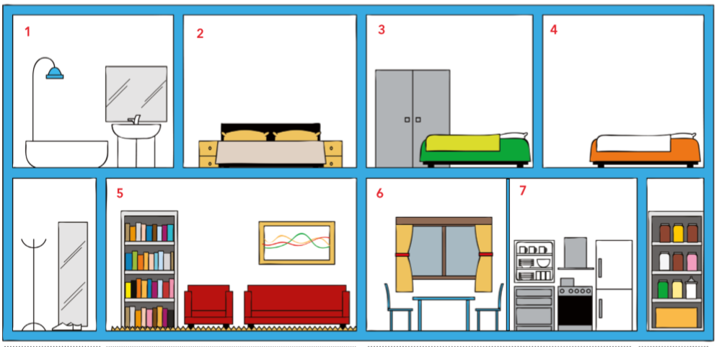

- 3 Read the sentences. Circle the words in bold.
Pročitaj rečenice. Zaokruži podebljanje riječi u rečenici.
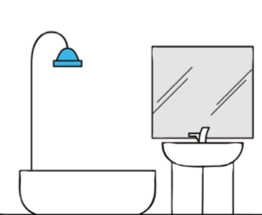

We take a bath in the bathroom. We sleep in the bedroom.
Kupamo se u u kupaonici. Spavamo u spavaćoj sobi.
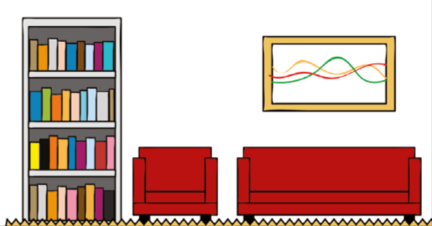
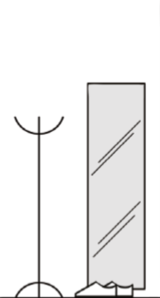

We take our coats off in the hall. We watch TV in the living room.
Skidamo jakne u hodniku. Gledamo televiziju u dnevnom boravku.

We eat in the dining room. We cook in the kitchen.
Jedemo u blagavaonici. Kuhamo u kuhinji.

We keep our food in the pantry.
Hranu držimo u smočnici.

- 4 Match the rooms to their names.
Spoji prostorije u kući s njihovim nazivima.

a bathroom
kupaonica

a bedroom
spavaća soba

a kitchen
kuhinja

a dining room
blagavaonica

a living room
dnevni boravak

- 5 Make your own house plan.
Izradi sam svoj plan kuće.
a) Cut the rooms out. Glue them on the empty spaces.
Izreži sličice prostorija u kući. Rasporedi ih i nalijepi u prazne prostore kuće.
b) Write the names of the rooms in the empty frames.
Upiši nazive za sobe u prazne okvire.
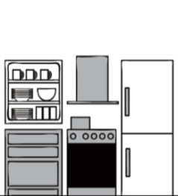 | 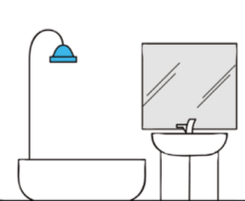 | 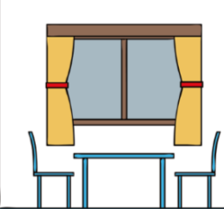
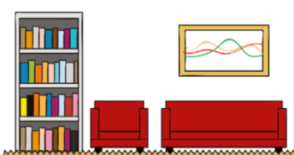 | 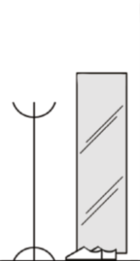 | 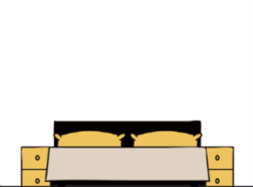

- 6 There is furniture in every room.
U svakoj se sobi nalazi namještaj.
a) Listen to your teacher read out the names for the furniture.
Poslušaj svog učitelja / učiteljicu kako imenuje namještaj.
b) Point to the furniture you hear.
Pokaži dio namještaja koji čuješ.
c) Read out the names for the furniture.
Pročitaj nazive za namještaj.

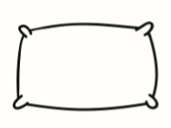  a pillow  jastuk | 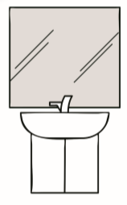  a washbasin  umivaonik | 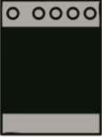  a cooker  štednjak
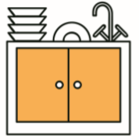  a sink  sudoper | 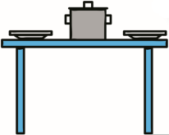  a table  stol | 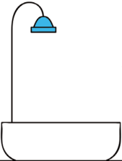  a bathtub  kada
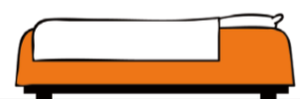  a bed  krevet | 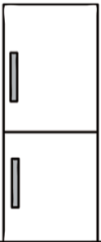  a fridge  hladnjak | 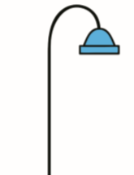  a shower  tuš
a  a wardrobe  ormar |  | 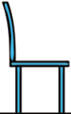  a chair  stolica

- 7 Explore the rooms.
Istraži prostorije u kući.

Where can you find the furniture?
Gdje se nalazi namještaj?

a) Write a number of a room next to a furniture found in it.
Napiši broj sobe pored namještaja kojeg si pronašao u toj sobi.

2  a pillow | a washbasin | a cooker
a sink | a table | a bathtub
a bed | a fridge | a shower
a  a wardrobe |  | a chair

b) Write the sentences using your answers from task 7 a).
Napiši rečenice uz pomoć odgovora iz zadatka 7 a.

1 The pillow is in in the bedroom.
Jastuk je u spavaćoj sobi.

2 The washbasin is in the __________________________ .
Umivaonik je u kupaoni.

3 The _____________________________ is in the kitchen .
Štednjak je u kuhinji.

4 The sink is in the_______________________________ .
Sudoper je u kuhinji.

5 The _______________________ is in the dining room .
Stol je u blagavaonici.

6 The ___________________________ is in the bathroom.
Kada je u kupaonici.

7 The bed is in the ______________________________ .
Krevet je u spavaćoj sobi.

8 The _____________________________ is in the kitchen.
Hladnjak je u kuhinji.

9 The shower is in the ___________________________.
Tuš je u kupaonici.

10 The __________________________ is in the bedroom .
Ormar je u spavaćoj sobi.

11 The chair is in the______________________________.
Stolica je u blagavaonici.

